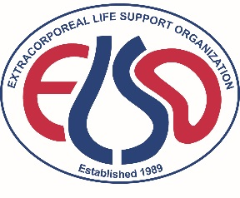
Extracorporeal Life Support in Adult Critical Care
An ELSO Sponsored Course
Located at The Thomas Jefferson University
August 22-25, 2018
Philadelphia, PA

First Name: Last Name: Degree:

Institution

Address

City State Zip

Country

Telephone:

E-mail Address:
Electronic Signature:

REGISTRATION FEES

$3,500 Extracorporeal Life Support in Adult Critical Care

Payment: Please make check in U.S. funds drawn on a U.S. bank payable to ELSO or charge to a VISA, Discover, American Express or MasterCard.

Check Attached (U.S. Bank in U.S. dollars) Credit card
I hereby authorize ELSO to charge my credit card account the U.S. equivalent of the total registration fee.

Card # Exp. Date /

Signature:

Name on card printed:

Email for Receipt:

Mail to: ELSO Office, 2800 Plymouth Rd, Building 300, Room 303, Ann Arbor, MI 48109-2800 USA.
FAX if paying by credit card to: 734-998-6602. DO NOT EMAIL CREDIT CARD DATA.
Questions: E-mail: ECMOTraining@elso.org or call 734-998-6600.

Registration Policies: • Payment MUST accompany form. • Cancellations in writing or by FAX only.
• No phone cancellations. • Before June 15, 2018 50% refund, after June 15, 2018 no refund.

Please note that ELSO will be taking photographs and video during this course. Your registration for and participation at this course constitutes your permission for ELSO and its affiliates and designees to use photographs or videos in which you may appear for publicity or promotional uses in any medium whatsoever without compensation.

